Go to bucket and click create lifecycle rule

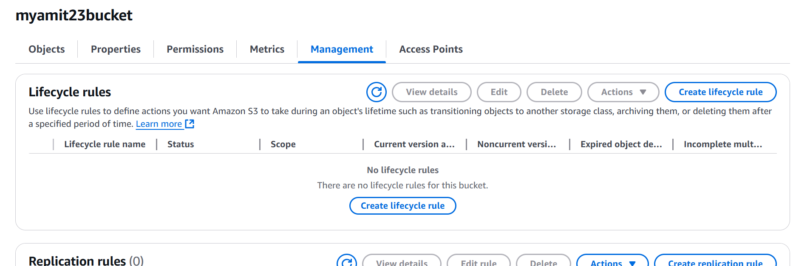

Define the lifecyle rule

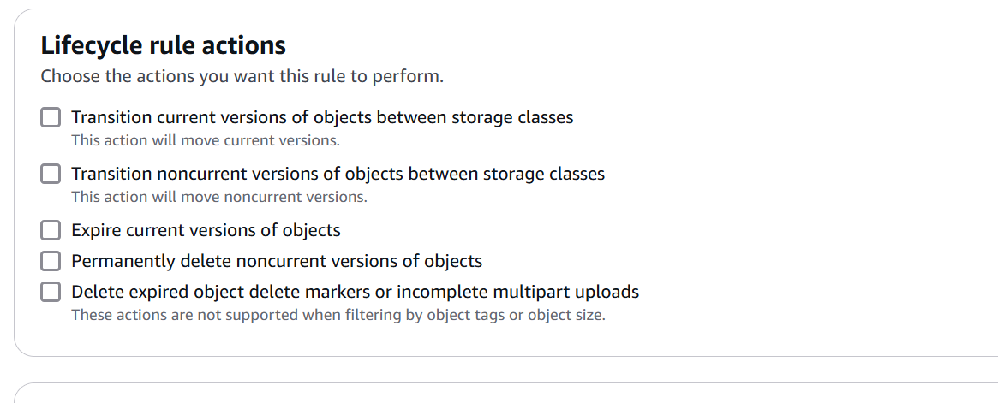

Check mark

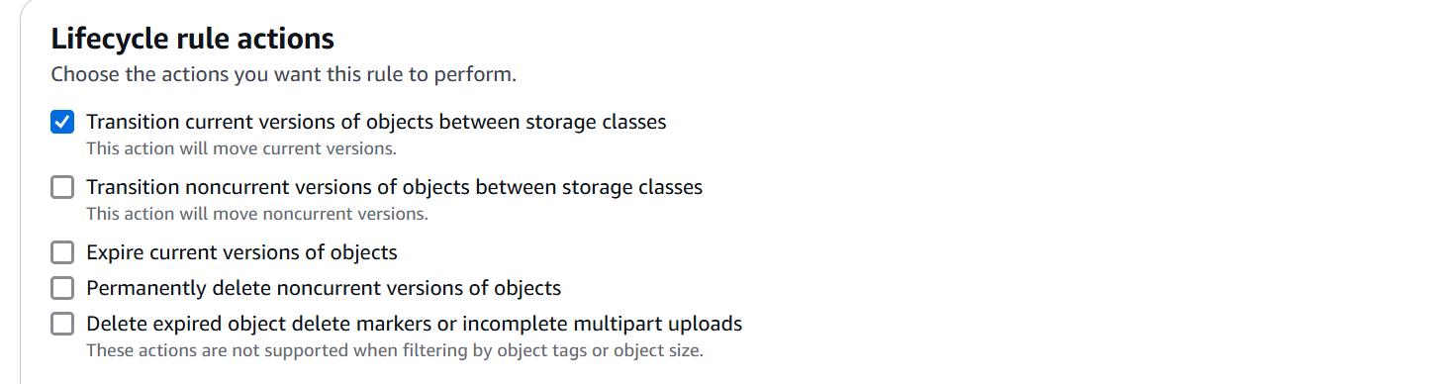

Click Transition

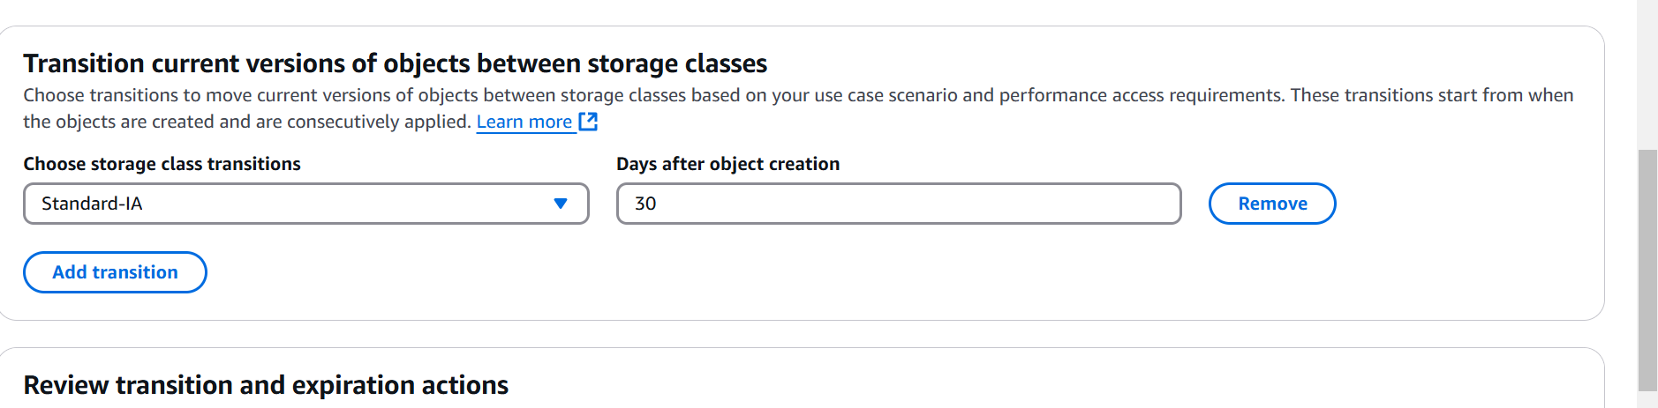

Add one more rule

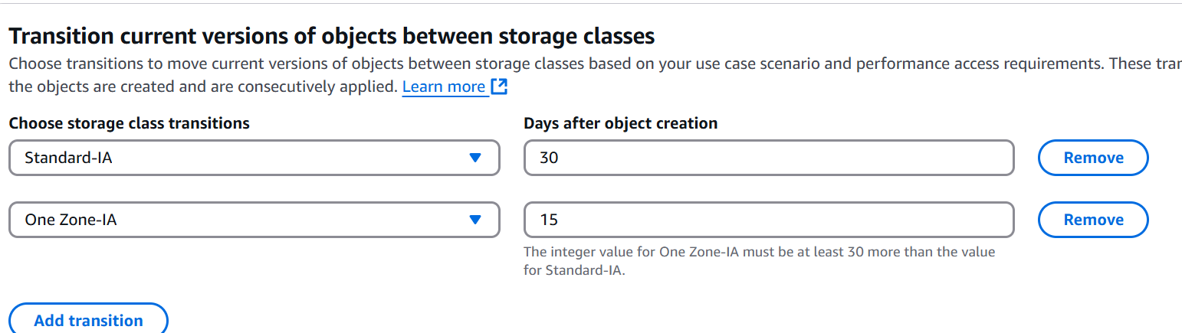

Create the rule